**BRIGGS PUBLIC LIBRARY**

**Annual Report**

**2012**

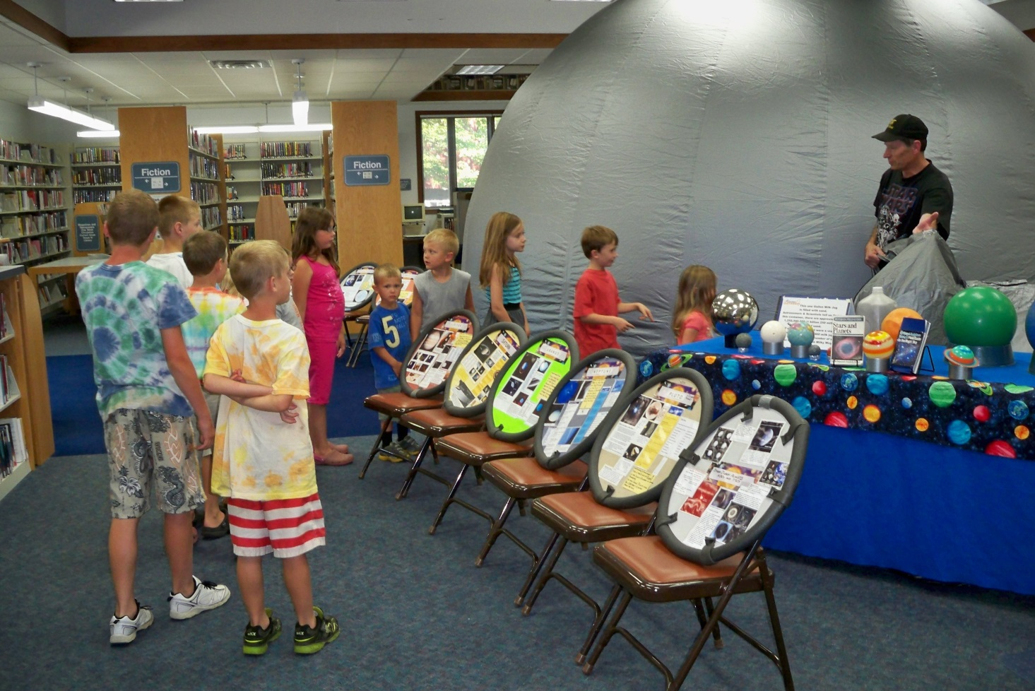

**Disclaimer Statement for the 2012 Annual Report of the**

**Briggs Public Library**

# Libraries in the State of Michigan are required by law to report on financial and statistical information for the most currently completed fiscal year.

# Financial and statistical information (unless otherwise noted) has been drawn from year-end figures for fiscal year 2011-2012, covering the time period of July 1, 2011 through June 30, 2012.

“In 2012” refers to the calendar year, January through December of 2012. Unless otherwise noted, information about library services, events, and other activities is drawn from the time frame of January 2012 through December 2012.

**NEW TO THE LIBRARY IN 2012**

**♦♦♦♦♦♦♦♦♦♦♦♦♦♦♦♦♦♦♦♦♦♦♦♦♦♦♦♦♦♦♦♦♦♦♦♦♦♦♦♦♦♦♦♦♦**

The Library applied for and received a grant from the Tri-County Electric People Fund. These funds enabled the Library to purchase an Early Literacy Station. The station has over 50 educational games for children ages 2-10 on it. The games cover seven curricular areas and are selected to support state and national curriculum standards. Elf, a child-safe internet browser which can direct kids to over 100 safe educational websites was included with the system. Parents can download the browser to a flashdrive and install it on any internet-connected Windows PC with a broadband connection.

A walkup catalog computer was added to the adult side of the Library. This allows patrons who are looking for materials to not have to wait in line behind individuals signing onto or printing from the public internet stations.

The Library repurposed an old counter top to create a second counter for the public computers which allowed for the addition of an eighth public internet station.

**Affiliated Organizations**

**♦♦♦♦♦♦♦♦♦♦♦♦♦♦♦♦♦♦♦♦♦♦♦♦♦♦♦♦♦♦♦♦♦♦♦♦♦♦♦♦♦♦♦♦♦**

The Library Board is officially responsible for the operations of the Library. The nine member appointed board is comprised of seven City of St. Johns residents and two Bingham Township residents. The Board is responsible for approving the Library’s annual budget, controlling the expenditure of Library funds, maintaining the Library facility and grounds and adopting the policies under which the Library operates.

The goal of the Briggs Public Library Foundation is to ensure the long term funding for the Library through the development of an endowment fund. The Board continues to recruit new Board members and look for possible donors. Lighthouse and maritime history author, Frederick Stonehouse was the featured speaker at the organization’s seventh annual “Authors and Honors Night” in April.

Briggs Public Library Friends is an organization that supports the library services through volunteer activities. They operate a book sale in the Library warehouse on the first and third Saturdays of the month, assist with major Library programs, donate specialized materials to individuals or groups in need and recycle books.

White Pine Library Cooperative is a regional organization that serves 48 public libraries and their various branches and 12 libraries of other types in 12 Counties. They assist the Library with affordable staff education, group discounts on library products, inter-library loan delivery, and keep the Library informed on matters affecting the Library at the State level.

### OUTREACH PROGRAMMING & COMMUNITY INVOLVEMENT

**♦♦♦♦♦♦♦♦♦♦♦♦♦♦♦♦♦♦♦♦♦♦♦♦♦♦♦♦♦♦♦♦♦♦♦♦♦♦♦♦♦♦♦♦♦**

The library provided special storytimes to several daycares and school groups, Adventure Club, Rainbow Place Preschool, Kids Zone Daycare, Little Wings and Kids Zone Kindergarten Readiness.

In May staff visited area elementary and pre-school aged children in both the public and private schools to promote the summer reading program, “Dream Big Read.”

Library staff assisted with the “Cops N’ Kids” program sponsored by the St. Johns Police Department. Staff continue to use their expertise in children’s literature to select the books that the officers handout to the children.

150 trick or treaters visited the Library on October 31th for “An Event So Good Its Scary,” princesses, pumpkins and ghosts were able to select Halloween goodies from an array of books and toys.

The St. Johns Lions & Lioness Club conducted vision screenings at the Library for children between ages of one and five as part of Project KidSight and their P.E.E.K. initiative.

In 2012, the fifth graders from Gateway North Elementary and Eureka Elementary came to the Library for a tour, book talk and some brief computer/internet resources instruction.

The 2nd graders from St. Joseph Elementary came to the Library in December for a holiday program including stories, a game and a craft.

In keeping with the summer reading program theme, “Dream Big Read”, the Library’s float entry in the Mint Festival Parade focused on the evening skies and bedtime.

During the past year the library has helped coordinate or serve as a drop off location for a variety of charitable giving opportunities. In November food items were collected and distributed to the local food bank. During the holiday season the Library was a drop off location for Toys for Tots filling the receptacle several times. Additionally, patrons donated mittens, scarves, and hats which were given to local charities for distribution.

Page 4

**LIBRARY PROGRAMMING 2011-2012**

**♦♦♦♦♦♦♦♦♦♦♦♦♦♦♦♦♦♦♦♦♦♦♦♦♦♦♦♦♦♦♦♦♦♦♦♦♦♦♦♦♦♦♦♦♦**

Three hundred ninety-five programs serving 9,625 individuals were offered by the Library in 2011-2012. Programming can be both active and passive. It is designed to reach a variety of age groups, and occurred both in the Library and at outreach locations.

**CHILDREN & YOUNG ADULTS**

**♦♦♦♦♦♦♦♦♦♦♦♦♦♦♦♦♦♦♦♦♦♦♦♦♦♦♦♦♦♦♦♦♦♦♦♦♦♦♦♦♦♦♦♦♦**

The Library’s primary programming focus is children’s programming. There were 337 program offerings targeted at children ages twelve and under with an attendance of 8,969 in 2011-2012. Library staff works diligently to keep the programs fun and entertaining while trying to promote literacy and life long learning.

From “By the Light of the Moon” to “Plenty of Penguins” to “Reading Rocks,” storytimes remain popular with the public and form the foundation of children’s programming. These themed adventures feature wonderful tales, creative movement, songs and crafts. The Library offers fall, winter/spring and summer sessions for Chapter Chatter (ages 6-8), Pre-Readers (ages 4,5,6), Toddlers (ages 2 and 3) and Lapsit (ages 12-24 months). Both daytime and evening sessions are available with the exception of Chapter Chatter which occurs only in the evening.

“Make Reading “Mo” Fun” was the theme for March Is Reading Month 2012. The series of three programs were offered one each week at a different time of the day and featured stories, a craft and games based on the popular children’s books by author Mo Willems.

In April, the Easter Bunny hopped into Briggs Public Library for a visit. The program included a photograph of each child with the Easter Bunny as well as stories, games, a craft and a sweet treat.

Three meetingsof the Junior Readers Book Club, kids ages 7-9, took place in 2012. The group read the books “February Friend,” “Alien Ice Cream,” and “The Clue in the Corn Maze.” The craft, game and even the snack focused on the theme of the various books.

Three programs were offered for Tweens (ages 9-12) in 2012. In April cowpokes journeyed to the “Wild West” where they played Dodge City Hangman and made their own covered wagon. At the July program participants snacked on hotdogs and smores while they enjoyed “Tales Around the Campfire.” A Christmas Craft workshop was held in December.

“Dream Big Read” and “Own The Night” were the themes for the Summer Reading Program in 2012. 283 children and 43 young adults kept track of their summer reading while participating in a variety of guessing contests and informational activities all focused on exploring the evening skies.

For the summer reading program finale, stargazers enjoyed learning about the night sky inside a portable mylar planetarium dome. Face painting and refreshments rounded out this unique event.

Santa journeyed from the North Pole to the Library in early December to visit with local children. Over three days, 235 children sat on Santa’s lap and told him what they wanted for Christmas. Participants also enjoyed listening to the Caroling Kids at Briggs, playing seasonal games, doing crafts and eating homemade cookies.

# **ADULT**

**♦♦♦♦♦♦♦♦♦♦♦♦♦♦♦♦♦♦♦♦♦♦♦♦♦♦♦♦♦♦♦♦♦♦♦♦♦♦♦♦♦♦♦♦♦**

Once a month, Library staff travels to Hazel I. Findley County Manor, Clinton Commons, Suntree, and Grace Haven to offer residents there the chance to obtain library materials without having to physically journey to the Library.

The Library offers computer programs designed specifically for adults who are new to the world of computers and the Internet. The two-part courses occur four times a year focusing on a different topic each session like mouse and keyboard basics, working with Windows Word and an Introduction to the Internet.

A number of adults participated in the Adult Summer Reading Program, Between The Covers. A gift certificate or prize was given out every week with the grand prize being dinner and a movie for four. Local business owners donated a number of the give aways.

In June the Library offered a class on how to borrow free eBooks and downloadable audio books from the library. The class covered all the basics -- setup, downloading, and which devices support library eBooks.

Briggs Library started the BOOKAHOLICS book club in June. The group meets at Bruno’s Wonder Bar on the 3rd Thursday of each month for a relaxing evening of good books, conversation, food and drinks.

Makayla Smith from Saving With Style hosted a coupon class in May. She covered topics like sale cycles, where to find coupons and how to maximize ones shopping dollars at local stores.

**OTHER ACTIVITIES**

**♦♦♦♦♦♦♦♦♦♦♦♦♦♦♦♦♦♦♦♦♦♦♦♦♦♦♦♦♦♦♦♦♦♦♦♦♦♦♦♦♦♦♦♦♦**

The St. Johns / Konan-shi Friendship Society held their 16th annual art reception at the library on March 1st. The festivities featured a combined Elementary Chorus under the direction of Mrs. Shirley Anne Ries.  The artwork of St. Johns elementary and middle school students was displayed during the month of March alongside student art from Japan

Representatives from the Southeast Michigan Ghost Hunters Society visited Briggs Public Library on June 7th. The SEMGHS shared details about their investigations into paranormal activity across the country over the last 16 years. Their investigations have been featured on the Discovery Channel’s “A Haunting,” and participants got to see the results of those investigations.

A Schwan’s Truck Load Sale was held at the Library in October. The fundraiser generated $383 which will be used to fund an author visit in June of 2013.

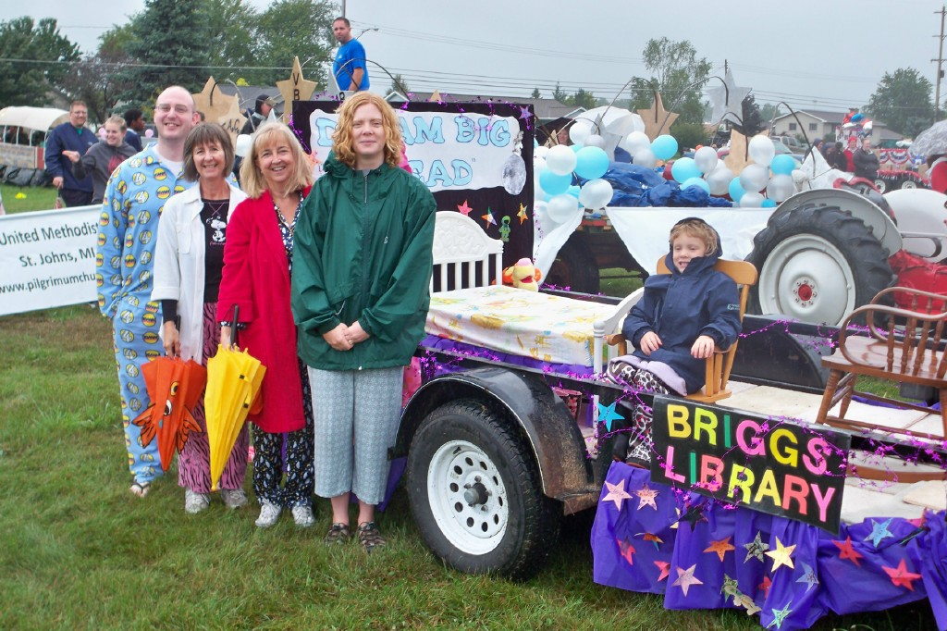

**Briggs Public Library**

**Registration and Visits FY 2011-2012:**

**Registered Patrons and Visits**

The Library continues to be a popular place to visit. People come for a variety of reasons but the three most common are to check out materials, computer access and programs. Total number of visits to the Library increased even with the Library adding two and half additional closure days for financial reasons. The number of active patrons decreased by 1,400 individuals largely due to the fact that the Library now requires all households outside its service area to pay a user fee.

**Active Library Patrons:**

The formal service area for Briggs Public Library is the City of St. Johns and seven neighboring townships. Approximately half of the library’s active patrons are city residents with the remainder being divided between the townships largely based on the township’s proximity to the Library.

|  |  |  |  |  |
| --- | --- | --- | --- | --- |
| **Direct Service Area** | FY 2011-2012 | FY 2010-2011 | FY 2009-20010 | FY 2008-2009 |
| City of St. Johns | 4,554 | 4,649 | 4,529 | 4,677 |
| Hazel I Findlay | 23 | 24 | 19 | 18 |
| Clinton Commons | 16 | 14 | 12 | 20 |
| Suntree | 21 | 16 | 18 | 20 |
| Grace Haven | 11 | 10 | 14 | 9 |
| Bengal | 467 | 506 | 503 | 535 |
| Bingham | 1,309 | 1,377 | 1,374 | 1,411 |
| Dallas | 570 | 595 | 571 | 607 |
| Greenbush | 820 | 861 | 839 | 901 |
| Olive | 533 | 567 | 576 | 605 |
| Riley | 435 | 434 | 431 | 458 |
| Westphalia | 107 | 105 | 101 | 117 |

As residents of the City of St. Johns, the library extends borrowing privileges to the individuals living at the Hazel I. Findlay Nursing Home, Clinton Commons Residential Community, Suntree Apartments and Grace Haven Assisted Living. They are classified separately because library staff provides residents at those facilities the opportunity to checkout library materials once a month at their residence. An annual fee of $50 a household is assessed for persons not residing in the Briggs’ service area. This nominal fee provides all individuals residing at that address with access to all the Library’s services including interlibrary loan, the downloadable collection and programs. Approximately 73 households in 2011-2012 took advantage of the non-resident user fee to make use of the Library’s resources.

**Briggs Public Library Funding Sources**

**Appropriations, Millages, and Township Contributions**

The largest single source of revenue for the Library is from the City of St. Johns, which funds the Library with appropriated funds equal to 0.9845 mills. In FY 2010/2011, funds from the City of St. Johns totaled $190,534 or 48**%** of the Library’s operating budget. The residents of Bingham Township have continued to support Library funding with a 0.497 mill levy. Revenue received from the Bingham Township millage in FY 2011/2012 accounted for 14**%** or $54,211 of the Library’s operating budget. Voluntary contributions from surrounding townships totaled $6,203 last year and accounted for 2**%** of Library operating funds.

**Penal Fines**

The allocation of penal fines is based on the total number of people in a library’s legal andcontractual service area; however, the collection and distribution of penal fines is often misunderstood. Penal fines are fines assessed for criminal and civil violations of the Michigan State Penal Code. Most penal fines are assessed for speeding violations and overweight trucks.

The dollar value of penal fines assessed is solely at the discretion of county court judges, and therefore penal fines can vary widely from year to year and from county to county. Additional factors such as parallel ordinances, law enforcement manpower, and the sentencing and collection of fines can also dramatically influence penal fine revenue. Clinton County collected and distributed $95,209 in penal fines during FY 2011/2012 to Briggs Public Library accounting for 25**%** of the total operating revenue for the Library.

**State Aid**

In order to receive state aid, libraries must comply with certification requirements for library staff. The amount of state aid received is based on the population served. For FY 2011/2012 state aid for the Briggs Public Library was $11,946. In 2011/2012 state aid was approximately 3% of the Library’s operating revenue. This figure is higher than normal due to receiving three checks during the year instead of the normal two.

**Donations**

Many libraries receive donated monies from people who value libraries and the services they provide. While the library may receive several sizable donations during the year most are for small amounts. The total amount of donations received can fluctuate widely from year to year. In FY 2011/2012 the Library received $16,557 in donated funds, comprising approximately 4**%** of the budget.

**Other Local Revenue**

## Fines, fees, and interest from invested funds comprise the final component of Library revenue. In January of 2012, the Library started charging $.10 a day on overdue materials with the exception of videos which were already $1.00 a day. For FY2011/2012, $18,228 of revenue, or 5% of operating funds, came from this source.

As a governmental entity, Briggs Public Library is required to submit a report to the State of Michigan by February 1st of each year. The Library is also audited on an annual basis as part of the City of St. Johns audit.

Library revenue continues to decline. Penal fine revenue decreased by $13,039 and property taxes dropped by $5891.75 in 2011-2012. Since 2006-2007 the Library has seen its annual operating revenue decline by $93,430. Going forward, the Library is facing some tough financial decisions regarding how to maintain its current level of operations/services and yet plan for the changes the future will bring.



The Library also does several fundraisers a year from collecting change in our dino bank to having a Schwan’s Truck Load sale. Labels for Education are collected to help provide additional children’s programming resources. The local Kiwanis Club donates money to the Library for the purchase of two children’s picture book a month and the Lions and Lioness Clubs donated funds on an annual basis often to supplement the large print collection. The Library greatly appreciates those individuals who support our fundraising efforts and who give donations on an annual basis. Without their support a lot of the extra touches that make the Library programs and services unique and special would not be possible.

Each contracting governmental unit funds the library in three ways: general fund support in the form of a millage, designated or appropriated, or an annual donation; penal fines and state aid, both of which are based on population. When these different sources are added together they reflect each governmental unit’s total monetary support of the library.

**Library Expenditures:**

The Library is extremely conscientious of how it expends the resources entrusted to it by the public. The Library Board and staff work hard to target available funds to the collection, programming and technology where patrons receive the greatest tangible benefit. This becomes harder every year with the rising costs of facility maintenance, utilities, medical insurance, office and janitorial supplies, technology maintenance and even collection resources. The Library continues to make every effort to provide the community with a quality operation and to explore new and better ways to serve the public.

# **Briggs Public Library Services**

**The Collection**

The most recognized and popular service of a library is the lending of materials. The Library’s goal is to provide a broad base collection in a variety of formats and genres at various ability levels to meet the majority of patron’s educational and recreational literary demands. When selecting titles, staff takes into consideration the types of materials patrons are requesting and the authors, genres and formats that typically circulate well.

|  |  |  |  |  |
| --- | --- | --- | --- | --- |
|  | FY 2011-2012 | FY 2010-2011 | FY 2009-2010 | FY 2008-2009 |
| Books | 36,635 | 36,400 | 34,621 | 34,109 |
| Audio Books & Kits | 1,895 | 2,258 | 2,193 | 2,063 |
| Videos (DVD/VHS) | 2,353 | 2,382 | 2,723 | 2,563 |
| Print Subscriptions | 93 | 89 | 79 | 81 |
| Download Audio | 1,563 | 839 |  |  |
| Ebooks | 2,223 | 355 |  |  |
| Other | 10 |  | 26 | 27 |
| Total Collection | 44,772 | 42,423 | 39,642 | 38,843 |

### Circulation and In-Library Use

|  |  |  |  |
| --- | --- | --- | --- |
|  | Circulation/In Library Usage of Children’s Collection | Circulation/In Library Usage of Adult Collection | **Total Annual Circulation** |
| FY 2011-2012 | 54,276 items | 54,326 items | **108,602** |
| FY 2010-2011 | 50,424 items | 75,635 items | **126,059** |
| FY 2009-2010 | 67,760 items | 62,226 items | **129,986** |
| FY 2008-2009 | 62,192 items | 64,144 items | **126,336** |

Note: The Library saw a substantial decrease in circulation due to the decision to no longer participate in the Michicard program.

**Circulation by Direct Service Area**

Page 11 of 20

|  |  |  |  |  |
| --- | --- | --- | --- | --- |
|  | FY 2011-2012 | FY 2010-2011 | FY 2009-2010 | FY 2008-2009 |
| City of St. Johns | 54,629 | 40,856 | 43,979 | 43,310 |
| Hazel I Findlay | 60 | 71 | 689 | 938 |
| Clinton Commons | 71 | 86 | 342 | 440 |
| Suntree | 421 | 338 | 518 | 378 |
| Grace Haven | 74 | 23 | 217 | 76 |
| Bengal Township | 6,469 | 5,862 | 6,312 | 5,526 |
| Bingham Township | 13,385 | 13,327 | 15,138 | 14,444 |
| Dallas Township | 5,751 | 5,544 | 5,806 | 5,773 |
| Greenbush Township | 10,795 | 10,469 | 12,042 | 12,060 |
| Olive Township | 3,985 | 3,888 | 5,019 | 4,938 |
| Riley Township | 3,547 | 3,922 | 4,603 | 4,899 |
| Westphalia Township | 1,115 | 965 | 1,241 | 1,325 |

**Other Circulation**

|  |  |  |  |  |
| --- | --- | --- | --- | --- |
|  | FY 2011-2012 | FY 2010-2011 | FY 2009-2010 | FY 2008-2009 |
| Michicard: Essex Township | 2,394 | 4,908 | 4,849 | 4,164 |
| Michicard: Victor Township | 714 | 1,583 | 1,733 | 813 |
| Other MichiCard | 3,066 | 8,256 | 8,513 | 8,395 |
| In Library Usage | 1,193 | 5,406 | 9,614 | 9,412 |
| User Fee | 4,755 | 1,127 | 747 | 463 |

**Interlibrary Loan**

The state wide interlibrary loan system, MeLCAT, is a greatly appreciated and used service. The system provides access to library materials from all over the state. Patrons can request items from anywhere they can access the Internet and pick them up at their local Library. The system is a great way to find unusual items not available locally.

|  |  |  |  |  |
| --- | --- | --- | --- | --- |
|  | FY 2011-2012 | FY 2010-2011 | FY 2009-2010 | FY 2008-2009 |
| Materials Requested | 3,291 | 2,519 | 4,134 | 3,831 |
| Materials Loaned | 2,028 | 1,537 | 1,042 | 1,485 |
| Total Interlibrary Loan Transactions | 5,319 | 4,056 | 5,176 | 5,316 |

**Fuel Your Mind Digital Collection**

### The Library in conjunction with the White Pine Library Cooperative works with a company called Overdrive to provide the Fuel Your Mind downloadable audio and ebook collection. Patrons can login on to the site and download their selections to their computers or portable devices. In addition to the titles owned by the Cooperative, Briggs Public Library participates in the Advantage program through which titles are purchases by the Library for use solely by its patrons. The number of individuals making use of the downloadable collection continues to increase significantly each year.

### Electronic Resources & Computer Usage

Electronic resources are becoming increasingly popular with patrons. The Library provides its patrons with online access to the Encyclopedia Britannica, the Columbia Gazetteer and a database called A to Z which provides researchers with a wide variety of data/statistics on the individual states as well as the United States as a whole. The public continues to use the Library computer for a variety of purposes from searching for a job to filing taxes to communicating with family and friends. An increasing number of individuals are using their laptops to connect to the internet via the library’s WiFi signal.

|  |  |  |  |  |
| --- | --- | --- | --- | --- |
|  | FY 2011-2012 | FY 2010-2011 | FY 2009-2010 | FY 2008-2009 |
| Average Use Electronic Resources Per Week  Page 16 | 423 | 454 | 487 | 545 |
| Total Use of Electronic Resources Per Year | 22,007 | 23,616 | 25,325 | 28,353 |

**Reference Questions**

A wide variety of print and electronic resources are at the disposal of Library staff to assist patrons in locating information. Inquiries run the gamut from locating a map or form to requesting data on a particular medical condition to locating a recipe for an ethnic dish. Library staff are available to assist individuals by helping clients clarify what they are looking for, locating information resources, instructing people on the use of the resource(s) and assisting in its interpretation if necessary. Reference transactions may be done over the phone, in person or by using the e-mail address on the Library’s website.

|  |  |  |  |  |
| --- | --- | --- | --- | --- |
|  | FY 2011-2012 | FY 2010-2011 | FY 2009-2010 | FY 2008-2009 |
|  |  |  |  |  |
| Total | 13,628 | 12,421 | 11,718 | 11,525 |

**Tax Form Distribution**

Each winter, Briggs Public Library offers a number of tax publications to the public. Most are pre-printed forms distributed by the state and federal government. Library staff assists the public in locating additional forms via the Internet. The number and type of forms available at the Library decreases each year as the government distributes fewer forms and encourages tax payers to complete more of the process online. In January of 2011, federal government stopped mailing forms to households and Libraries became the only place to pick up print copies of the forms for free.

|  |  |  |  |
| --- | --- | --- | --- |
| Distributed | Federal | State | Lansing |
| FY 2011-2012 | 5,655 | 1,025 | 6 |
| FY 2010-2011 | 6,121 | 1,002 | 10 |
| FY 2009-2010 | 4,049 | 1,296 | 100 |
| FY 2008-2009 | 6,470 | 1,844 | 125 |

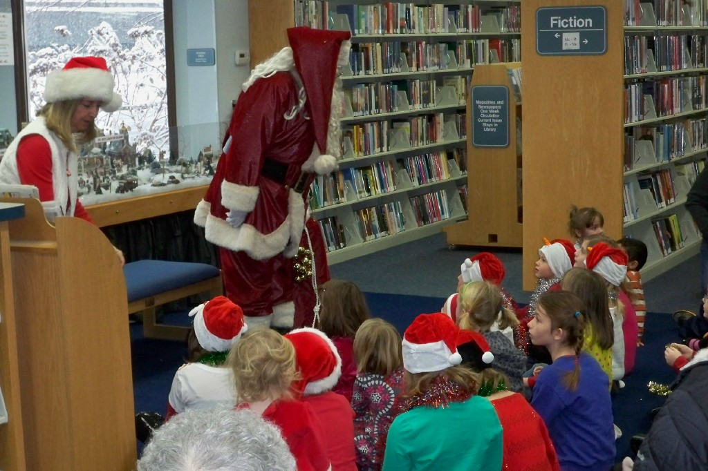

**Equipment and Facility Usage:**

A variety of equipment is available at the Library for public use. The public can fax documents and use the public copy machine. A number of individuals such as teachers, scrap bookers, church groups and 4-H youth make use of the Library’s Ellison Die machine and dies. A magnification station is available to enlarge printed or written material.

|  |  |  |  |  |
| --- | --- | --- | --- | --- |
| **Fax Machine** | FY 2011-2012 | FY 2010-2011 | FY 2009-2010 | FY 2008-2009 |
| Pages Sent | 1,600 | 673 | 1,557 | 1,146 |
| Pages Received | 249 | 969 | 374 | 319 |

|  |  |  |  |  |
| --- | --- | --- | --- | --- |
| **Public Printing** | FY 2011-2012 | FY 2010-2011 | FY 2009-2010 | FY 2008-2009 |
| Photocopies | 3,799 | 4,344 | 4,865 | 6,414 |
| Computer | 6,807 | 6,904 | 6,961 | 7,938 |

|  |  |  |  |  |
| --- | --- | --- | --- | --- |
| **Room Use** | FY 2011-2012 | FY 2010-2011 | FY 2009-2010 | FY 2008-2009 |
| Meeting Room | 26 | 39 | 48 | 49 |
| Bement Room | 302 | 314 | 305 | 233 |
| Quiet Study Room | 273 | 195 | 195 | 244 |

The rooms at the Library serve a variety of purposes. The local history collection and back volumes of the Clinton County News are housed in the Bement Room where they are primarily used for genealogical research. An internet station is located in that room for taking proctored exams and researching family history. Tutors, individuals taking tests and study groups make regular use of the Quiet Study Room. Besides being used for Library programs and Library Board Meetings, the Library Meeting Room hosted26 community meetings in 2011-2012.

