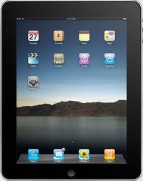
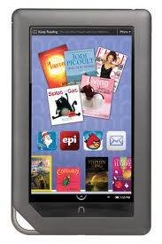
Using the Overdrive Media Console App
With Adobe for iPad, Nook (Color, HD) or Nexus

1. Download the Overdrive Media Console app to the device (1st time only)

2. Once downloaded, tap on app and then tap on “Get Books” (1st time only)
Go to settings
Tap on “Authorize”
Type in Adobe ID or create one

3. Inside the Overdrive app, find your Library (1st time only)
Tap “Get Books”
Tap “Add a Library”
Type in zip code or name of Library
Tap on “Briggs Public Library”
Tap the star next to Library name to add it to your list
Tap the Library name to view its digital titles

4. Browse/search/checkout
Tap on Overdrive app
Tap on “Get Books” in upper right-hand corner
Tap on Library name
Tap on “Account” to login bpl______________
Browse to see various titles in genres
Search for a specific title/author/subject
*Check available now box to view titles available now
At next screen, tap “Download” and select correct format (Kindle or EPUB)
Tap “Confirm & download”
Book is now added to bookshelf

5. Place holds (Maximum of 5)
If title is checked out, tap “Place a Hold”
Type in or confirm email address
Tap “Place a Hold”

6. Wish List (Unlimited)
At any title, tap “Add to Wish List” or tap on the grey bookmark
From Wish List you can add to cart, join waiting list, or remove titles

7. Reading eBooks
Tap on “Bookshelf” in upper right-hand corner
Tap on title you want to read and enjoy!

Briggs Public Library 108 East Railroad Street St. Johns, MI 48879 989-224-4702 www.briggspubliclibrary.org

